Online Blood Bank Management

Design Document

Version 1.0



Student Name: Aqeel Abbas
Supervisor Name: Ghulam Abbas

Revision History

Date (dd/mm/yyyy) | Version | Description | Author
20/07/2025 | 1.0 | Online Blood Bank Management System aims to bridge the gap between blood donors, recipients, and blood banks through an integrated web-based platform. The system will cater to different types of users, including administrator, hospital representatives, donors, and recipients, providing them with the necessary tools to handle all aspects of blood donation and transfusion management efficiently. | BC220200652

Table of Contents

- Introduction of Design Document 4
- Entity Relationship Diagram (ERD) 5
- Sequence Diagrams 6
- Architecture Design Diagram 13
- Class Diagram 14
- Database Design 15
- Interface Design 15
- Test Cases 18

Design Document

1.Introduction of Design Document:

A design document is a blueprint that outlines how a software system will be built. It translates user requirements into technical plans by detailing the system’s structure, components, interactions, and data flow. This document includes diagrams, specifications, and definitions that help developers understand what to build and how each part fits together. This document helps keep everyone on the same page, from developers and project managers to stakeholders. Without it, projects can quickly become disorganized, leading to misunderstandings, bottlenecks, and a product that doesn't meet expectations.

Design Document Components:
Our design document includes the following components:

- Entity Relationship Diagram (ERD):
The ERD visually represents the data structure of the system. It shows entities (such as Donor, Recipient, Blood Bank) and their relationships (such as one-to-many, many-to-many). The purpose of ERD is to design the logical structure of the database and understand how data is stored and connected.
- Sequence Diagram:
Sequence diagrams illustrate the interaction between different system components and users over time. They show the flow of messages in a specific use case. Its purpose is to visualize the flow of operations and communication between system components or users for a particular feature.
- Architecture Design Diagram:
Architecture diagrams give a clear way to represent system structures, relationships, and interactions, making it easier to design, understand, and communicate your ideas. It includes components like the front end, back end, database, APIs, and servers. The purpose of Architecture diagram is that it helps visualize how different parts of the system are organized and how they communicate
- Class Diagram:
Class diagram defines the structure of objects in the system including their attributes, methods, and relationships. It’s used in object-oriented programming. Class diagrams help the development team understand how to structure the backend of the system.
- Database Design:
The Database Design includes detailed information about how the actual database will be created. It includes tables, fields, primary key, foreign key and data types. This design helps the development team implement the database exactly as planned in the ERD and ensures the system handles data efficiently and correctly.
- Interface Design:
This covers the look and feel of the user interface, how users will interact with the system. It includes wireframes, screen layouts, navigation flow, and input/output forms. It helps make sure the system is easy to use and everything a user needs is clearly shown.
- Test Cases:
Test cases are detailed scenarios used to verify the system’s functionality. They define inputs, expected outcomes, and steps to execute. For example, a test case may check if the login function correctly handles a wrong password. These test cases are essential during testing to catch bugs and make sure the system meets the requirements.

Purpose of Design Document:
The main purpose of the design document is to create a clear and detailed plan for how the system will be built. After collecting and understanding the project requirements, the design document helps turn those ideas into a technical layout that developers, testers, and other team members can follow. It explains how the system will work, how users will interact with it, how the data will be managed, and how different parts of the system will connect with each other. In short, it acts as a bridge between the planning phase and the development phase.

Benefits of Design Document:
The design document provides many important benefits during software development. First, it helps avoid confusion by making sure that everyone on the team has a shared understanding of how the system is supposed to work. It also helps identify possible issues early, which saves time and reduces errors during development. Having a detailed design allows developers to write better code, makes testing easier, and improves communication between team members. Most importantly, it increases the chances of delivering a working system that meets the users’ needs and expectations.

2. Entity Relationship Diagram (ERD):

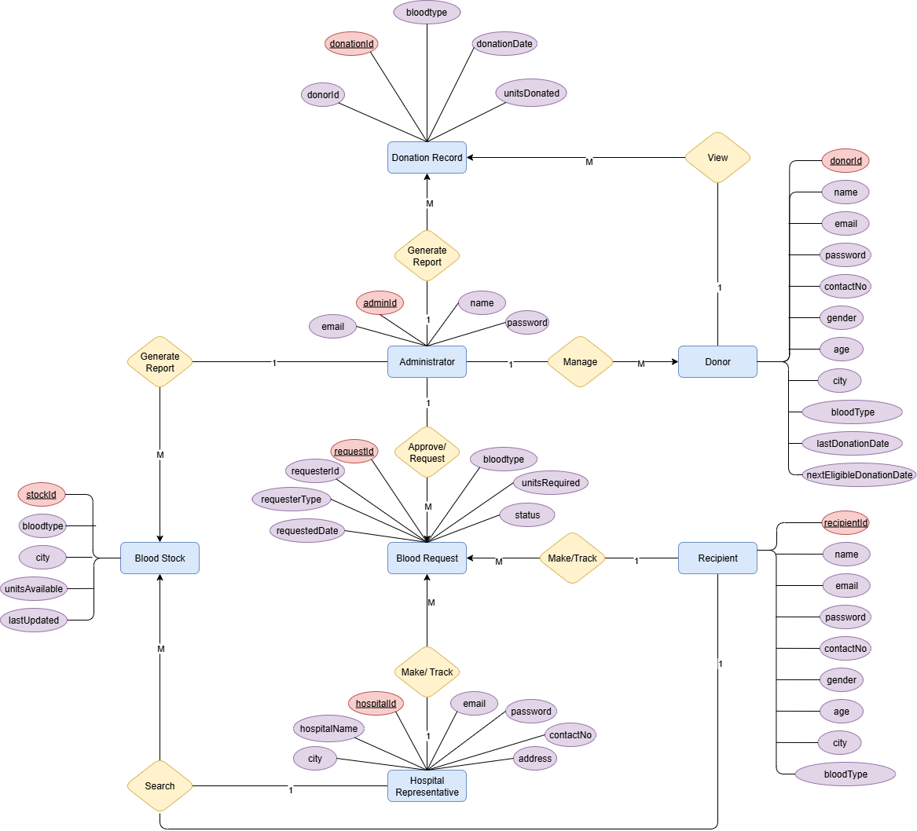

3. Sequence Diagrams:

The sequence diagrams according to our use case diagram (given in the SRS document) are given below:

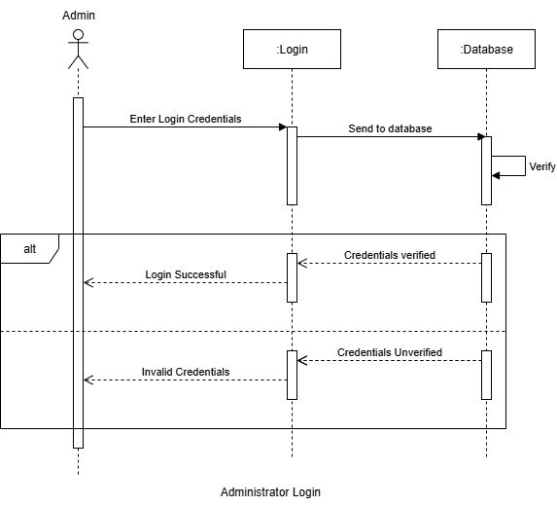

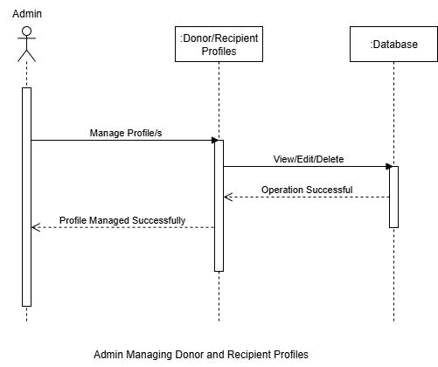

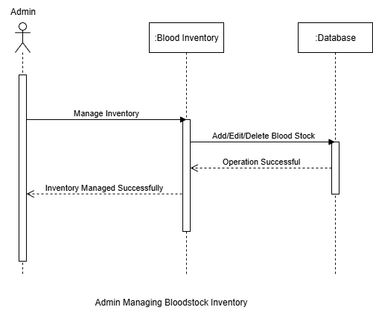
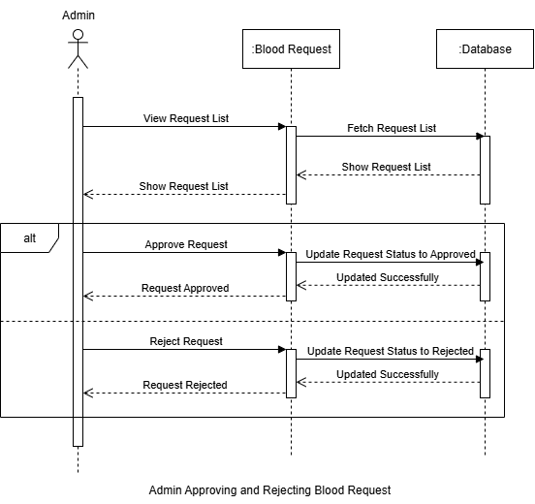

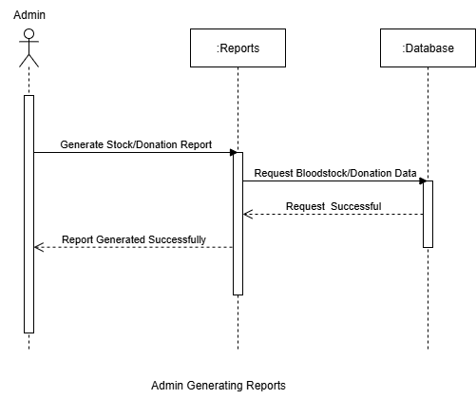
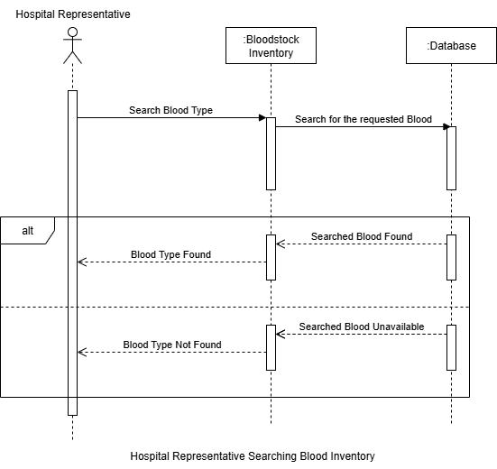
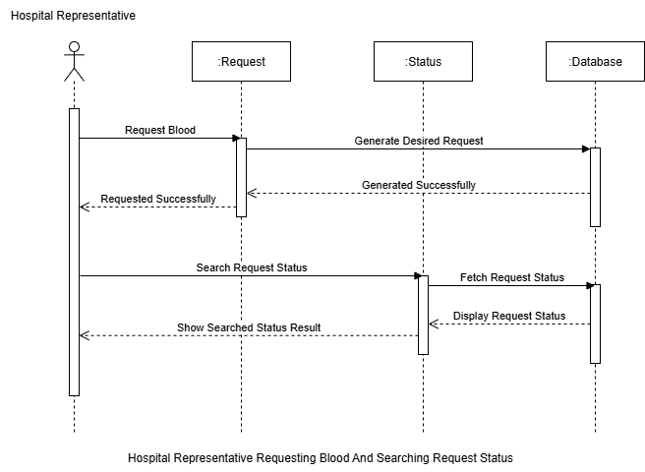
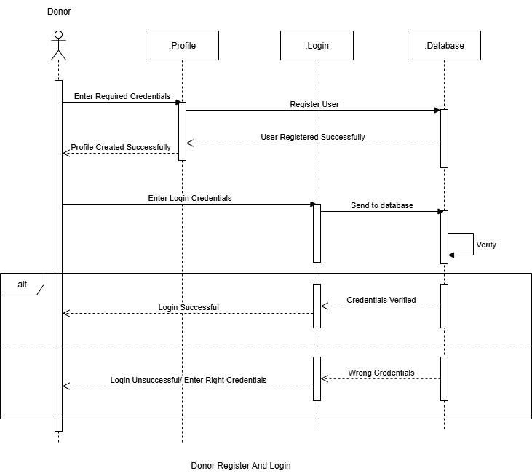
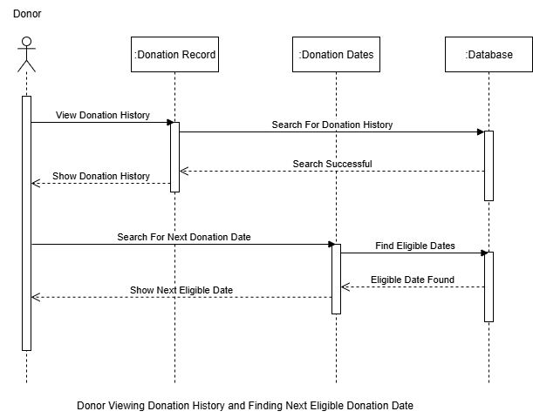
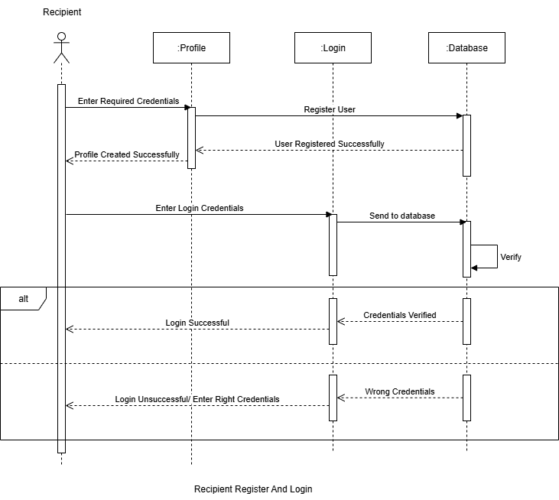
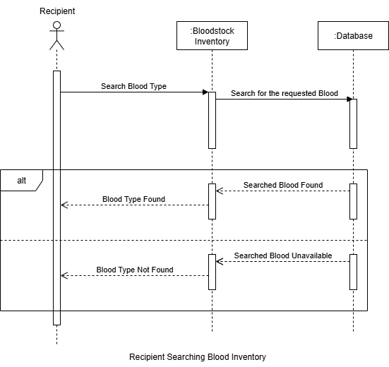
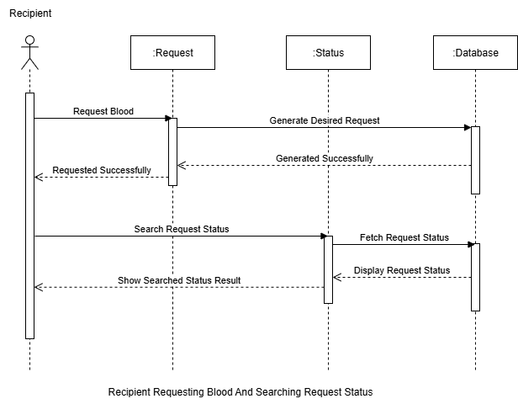

4. Architecture Design Diagram:

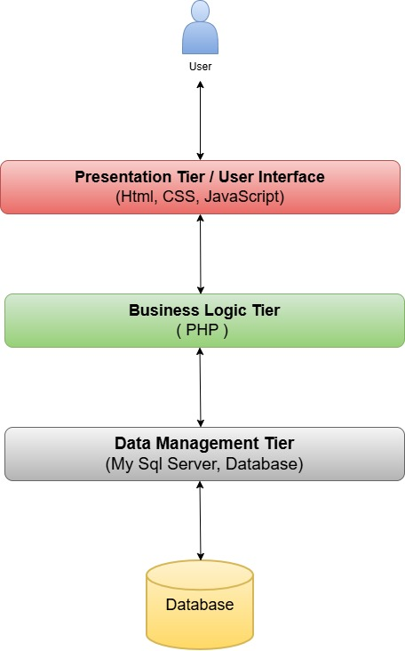

5. Class Diagram:
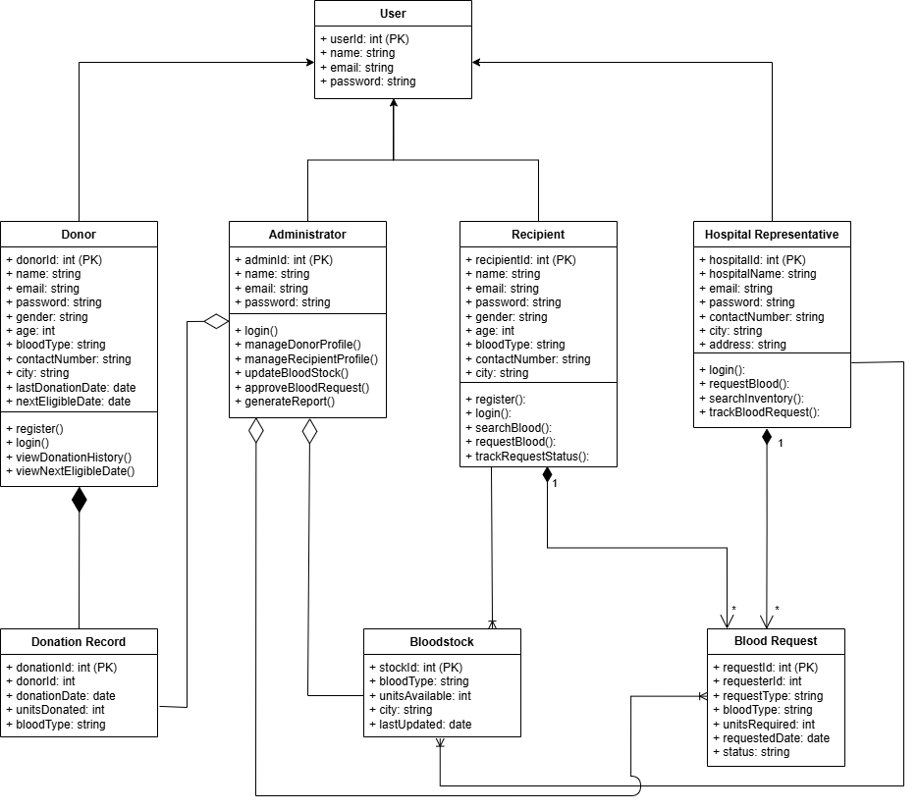

6. Database Design:

7. Interface Design:

These are some of the screenshots of user interface of our Online Blood Bank Management System Project:

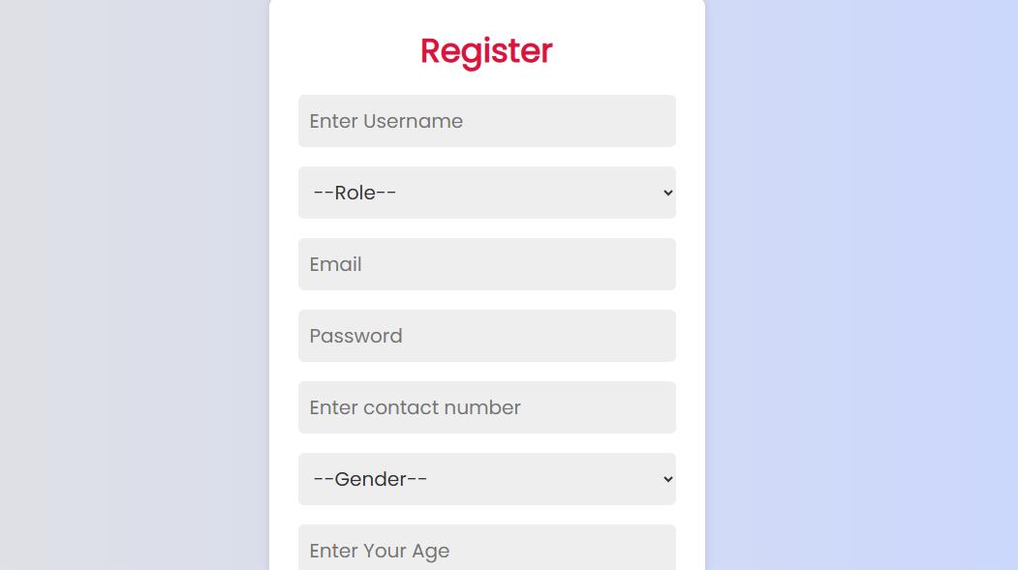

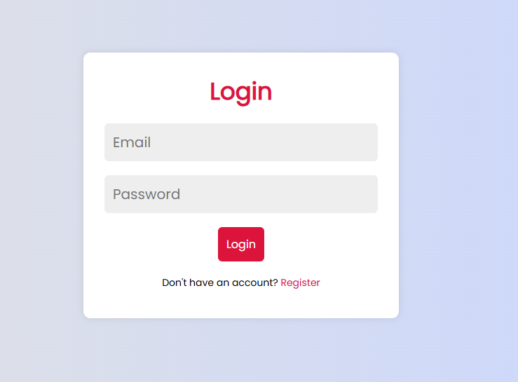

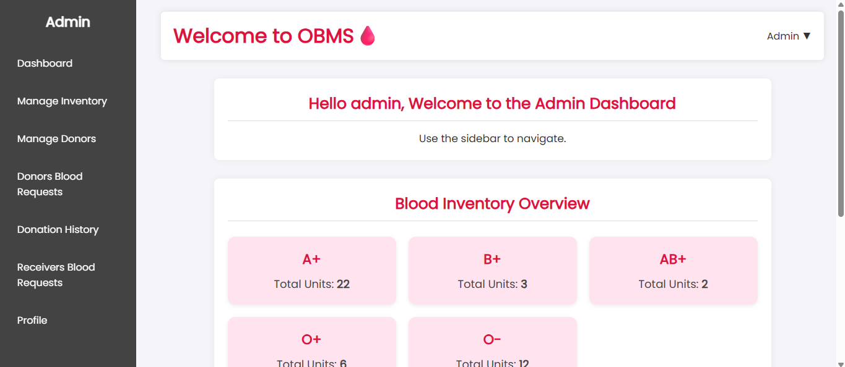

8. Test Cases:

Test Case #01: Administrator – Login

Test Case ID | TC01
Description | Login using correct admin credentials
Pre-condition | Administrator account must already exist in the system
Input | Email and Password
Expected Output | Access to admin dashboard
Pass/Fail | Pass
Post-condition | Administrator session starts and admin dashboard becomes accessible
Tested By | BC220200652

Test Case #02: Administrator – Manage Donor Profile

Test Case ID | TC02
Description | Edit and update donor information
Input | Donor ID and updated data
Pre-condition | Admin must be logged in and a donor pending account should exist
Expected Output | Donor profile updated
Pass/Fail | Pass
Post-condition | Donor profile is registered and they can now login
Tested By | BC220200652

Test Case #03: Administrator – Manage Recipient Profile

Test Case ID | TC03
Description | Edit recipient data
Input | Recipient ID and updated fields
Pre-condition | Admin must be logged in and a recipient pending account should exist
Expected Output | Recipient profile updated
Pass/Fail | Pass
Post-condition | Recipient profile is registered and they can now login
Tested By | BC220200652

Test Case #04: Administrator – Update and Maintain Blood Inventory

Test Case ID | TC04
Description | Update stock level for a blood type
Input | Stock ID, updated units
Pre-condition | Admin must be logged in
Expected Output | Inventory updated successfully
Pass/Fail | Pass
Post-condition | Inventory is now updated
Tested By | BC220200652

Test Case #05: Administrator – Approve and Reject Blood Requests

Test Case ID | TC05
Description | Approve or reject a blood request
Input | Request ID and decision
Pre-condition | A blood request must be submitted by recipients
Expected Output | Request status updated
Pass/Fail | Pass
Post-condition | Blood request status changed according to the action
Tested By | BC220200652

Test Case #06: Administrator – Generate Reports on Blood Stock and Donations

Test Case ID | TC06
Description | Generate a blood stock and donation report
Input | Date range and report type
Pre-condition | Relevant data must be present
Expected Output | Report downloaded successfully
Pass/Fail | Pass
Post-condition | Report generated as a excel file
Tested By | BC220200652

Test Case #07: Hospital Representative – Search Blood Inventory

Test Case ID | TC07
Description | Search for specific blood type in city
Input | Blood type and location
Pre-condition | Blood stock must exist
Expected Output | List of available units
Pass/Fail | Pass
Post-condition | Search results shows the available blood
Tested By | BC220200652

Test Case #08: Hospital Representative – Request Blood

Test Case ID | TC08
Description | Request a blood unit
Input | Blood type and required units
Pre-condition | Must be logged in and give the right info
Expected Output | Request submitted
Pass/Fail | Pass
Post-condition | Request submitted successfully
Tested By | BC220200652

Test Case #09: Hospital Representative – Search Blood Request Status

Test Case ID | TC09
Description | Track the blood request status
Input | Request ID
Pre-condition | A blood request must exist
Expected Output | Status displayed
Pass/Fail | Pass
Post-condition | Status of request is displayed
Tested By | BC220200652

Test Case #10: Donor – Register / Create Profile

Test Case ID | TC10
Description | Register new donor
Input | Form details
Pre-condition | Must not have an existing account
Expected Output | Donor account created
Pass/Fail | Pass
Post-condition | Account is created and pending approval
Tested By | BC220200652

Test Case #11: Donor – Login

Test Case ID | TC11
Description | Donor login with correct credentials
Input | Email and password
Pre-condition | Account must exist and credentials must be valid
Expected Output | Access to donor dashboard
Pass/Fail | Pass
Post-condition | Donor session started and dashboard is accessible
Tested By | BC220200652

Test Case #12: Donor – View Donation History

Test Case ID | TC12
Description | View past donation dates
Input | Donor ID
Pre-condition | Donation record must exist
Expected Output | Donation history displayed
Pass/Fail | Pass
Post-condition | Donation history is displayed
Tested By | BC220200652

Test Case #13: Donor – View Next Eligible Donation Date

Test Case ID | TC13
Description | View next donation date
Input | Donor ID
Pre-condition | Donation request has been made and approved by admin
Expected Output | Next eligible date shown
Pass/Fail | Pass
Post-condition | Next donation date is displayed
Tested By | BC220200652

Test Case #14: Recipient – Register / Create Profile

Test Case ID | TC14
Description | Register new recipient
Input | Must not have an existing account
Pre-condition | Account must exist and credentials must be valid
Expected Output | Recipient account created
Pass/Fail | Pass
Post-condition | Account is created
Tested By | BC220200652

Test Case #15: Recipient – Login

Test Case ID | TC15
Description | Login as recipient
Input | Email and password
Pre-condition | Account must exist and credentials must be valid
Expected Output | Access to recipient dashboard
Pass/Fail | Pass
Post-condition | Recipient session started and dashboard is accessible
Tested By | BC220200652

Test Case #16: Recipient – Search Blood by Type and Location

Test Case ID | TC16
Description | Search blood by type and city
Input | Blood type and location
Pre-condition | Blood stock must exist
Expected Output | Available blood units listed
Pass/Fail | Pass
Post-condition | Search results shows the available blood
Tested By | BC220200652

Test Case #17: Recipient – Request Blood

Test Case ID | TC17
Description | Submit a blood request
Input | Recipient info and blood details
Pre-condition | Must be logged in and give the right info
Expected Output | Request submitted
Pass/Fail | Pass
Post-condition | Request submitted successfully
Tested By | BC220200652

Test Case #18: Recipient – Search Blood Request Status

Test Case ID | TC18
Description | Check request status
Input | Request ID
Pre-condition | A blood request must exist
Expected Output | Status shown
Pass/Fail | Pass
Post-condition | Status of request is displayed
Tested By | BC220200652

